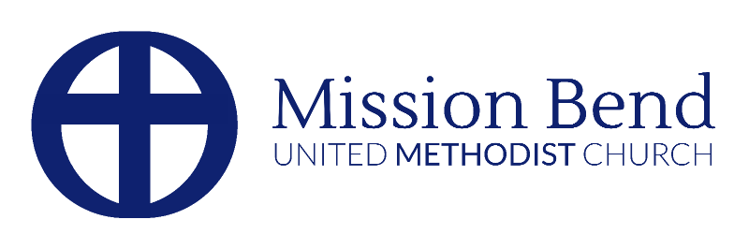
Welcoming Caring & Growing Together

Request for Use of Church Facilities

Date of Application: _____________ Event/Purpose: ______________________________
Name of Requesting Individual/Organization: ____________________________________
Contact Person_________________________ Phone_________________________
Email_______________________________________________________________
Purpose of Activity: ________________________________________________________
Day and Date of Use: _______________________________________________________
Time of Use (allow sufficient time for setup & cleanup): Start _________ End __________
Room(s) Requested: _______________________________________________________
Number of People Expected: _________________________________________________
Additional service providers (caterers, musicians, etc.): ____________________________
________________________________________________________________________

NOTE: Return of this completed form, with deposits to “Mission Bend United Methodist Church” is necessary before confirmation can be given.

By signing, I acknowledge I have read and agree with the Mission Bend United Methodist Church “Facilities Usage Guidelines and Rules.”

Requestor’s Signature: ________________________________ Date _________________
Approval Signature: ____________________________ Date _______________

OFFICE USE ONLY

Facilities Use (Circle One): Approved / Not Approved
Approval granted by (Signature): _____________________________________
Event Added to Church Calendar (Circle One): Yes / No
Deposits Rec’d (Amount): $___________ Check #_______ Cash____________
Balance Due: $_______ (fees) $_________ (remaining deposits)
Certificate of Liability Insurance received: ______________________________
Event Confirmation (1 month before event): ____________________________
Walk-Through Date: _______________________________________________

